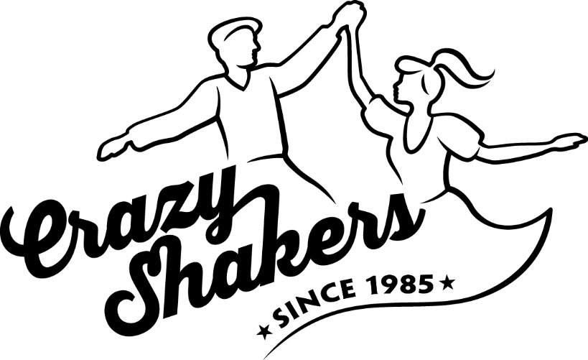Kurs Intermediate-Advanced 4

Kursleiter: Markus Berghahn & Paula Appenzeller

Ort: Club Silbando, Förrlibuckstrasse 62, 8005 Zürich

Uhrzeit: 18:30 – 20:00

|  |  |  |  |
| --- | --- | --- | --- |
| Tag | Datum | Kursleiter | Inhalt |
| 1 | 27.10.2024 | Paula & Markus | Footwork, bounce, rhythm |
| 2 | 03.11.2024 | Paula & Markus | Footwork, bounce, rhythm |
| 3 | 10.11.2024 | Paula & Markus | Basic dancing, body, harmony |
| 4 | 24.11.2024 | Paula & Markus | Basic dancing, body, harmony |
| 5 | 01.12.2024 | Paula & Markus | Lead & follow, connection, tension |
| 6 | 08.12.2024 | Paula & Markus | Lead & follow, connection, tension |